**The Structure of the Eye**

Label the parts of the eye and then fill out the table to describe the function of each part.

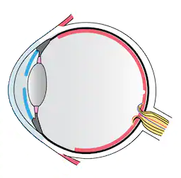

|  |  |
| --- | --- |
| **Name of Part** | **Function of Part** |
| Cornea |  |
| Iris |  |
| Pupil |  |
| Lens |  |
| Ciliary muscles |  |
| Retina |  |
| Optic Nerve |  |
| Choroid |  |
| Sclera |  |
| Aqueous humour |  |
| Vitreous humour |  |

1. What type of receptors are found in the eye and what do they detect? In which part of the eye are these receptors found?
2. Describe the path light takes from an object through the eye to the retina.

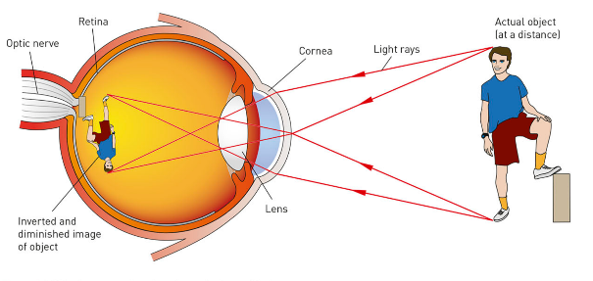

1. When the ciliary muscles pull on the lens it makes it thinner. How does this change the focal length of the lens?
2. State which of the two alternatives makes each of these statements true.
   1. Light entering the eye is refracted by the lens and the *cornea / retina.*
   2. To produce a clear image, light must be focussed on the *retina / lens.*
   3. The image travels as a series of *electrical / light* signals along the optic nerve to the brain.
   4. The aqueous humour is a clear fluid that lies between the cornea and the *retina / lens.*
3. Is the image formed on the retina a virtual or a real image? Explain your response.
4. What will happen to the pupils in your eye when you are:
   1. In a dark cinema
   2. Outside in the sun